Lab Report-Determination of Percent Carbonate in an Unknown
Name:
Date:
Course Number:
Instructor’s Name:

Tittle: Lab Report-Determination of Percent Carbonate in an Unknown
Abstract
Although Carbonate -carbon is an essential part of biochar-c, it leads to liming of properties of materials that interfere with the fraction stability of organic C fraction in biochars. to quantify carbonate-C in biochars, four methods were to be compared.; two indirect (acid treatment separation by filtration and acid fumigation) and two direct (thermogravimetric analysis and a titrimetric procedure). The acid fumigation method is preferred because biochars contain a high amount of carbonate-C (>0.3%wt) when determining the significance of the isotope of organic C in biochars. In contrast, the acid treatment with the filtration step overestimates the content of carbonate-C. If the TGA method is considered reliable if the main carbonate form is calcite in biochar’s, even though it can be inadequate for the samples with a considerable amount of carbonate-bearing minerals and whewellite example, magnesite that usually decomposes at <600 degrees Celsius. For our case, two methods were proposed. The ratio between predicted fixed C and the monument test. The total C (FC/TC were estimated using the value of (FC/TC)=-01081(H/C)2-0.1794(H/C) +1.0097
Introduction
The process of titration usually takes place where a certain solution is added to another solution in a way that the volume added will react under the same condition in an accurately measured volume. Titration is mostly used in qualitative analytical chemistry in order to determine the unknown concentration of an analyte identified. In most of the cases, titration is assocociated with acid base reactions. Besides, it may also involve other types of reactions. In this experiment, the type of reaction is the acid base titrations where neutralization tends to occur between hydroxide ions (OH-) and hydrogen ions (H-). As it is usually known, sodium hydroxide (NaOH) absorbs (CO2) carbon dioxide from the atmosphere to form sodium carbonate, Na2CO3. 2 NaOH(aq) + CO2(g) → Na2CO3(aq) + H2O(l)
Materials and Reagents
Anhydras Na₂CO₃
Distelled Water
Weighing balance
250ml flask
Parafilm
HCL solution
50ml beret
Method
Dry about 2.0 g of anhydras Na₂CO₃ was placed in a bottle for about 2hours and cooled. The bottle was then rinse your with distilled water and left to a little air between the neck and water surfaces. 17ml 6m HCL was then measured and water to the cylinder added and stirred. A mixture in the bottle and invert were added and continued stirring in order to get homogeneous mixture. Anhydrous Na₂CO₃ solution is standardized therefore there is no need to analyze the procedure
In order to be accurate, weigh out three samples of 0.20 to 0.25g of dried anhydrous Na₂CO_{3 into} two different 250ml flask In order to dissolve the carbonated. 50ml of distilled water was added and cover the flask with parafilm. Finally, the 50ml beret was rinsed with the solution of Hcl and fills it with the acid solution and records the readings.
Results and Data Analysis
Standardization of HCl solution
Average concentration
Reaction: Na₂CO₃(aq) + 2 HCl(aq) 2 NaCl(aq) + CO₂(g) + H₂O(l)
$$n_{HCl}=2×n_{{Na}_{2}{CO}_{3}} \\ =2×\frac{{mass}_{{Na}_{2}{CO}_{3}}}{105.99\frac{g}{mol}} \\ c_{HCl}=\frac{n_{HCl}}{V_{HCl}} \\ =0.018870\frac{mol}{g}×\frac{{mass}_{{Na}_{2}{CO}_{3}}}{V_{HCl}}$$

$$c_{HCl\left(1\right)}=0.018870\frac{mol}{g}×\frac{0.1089 g}{0.02033 L} \\ =0.1011\frac{mol}{L}$$
$$c_{HCl\left(2\right)}=0.018870\frac{mol}{g}×\frac{0.0927 g}{0.01814 L} \\ =0.0964\frac{mol}{L}$$
$$c_{HCl\left(3\right)}=0.018870\frac{mol}{g}×\frac{0.1129 g}{0.02087 L} \\ =0.1021\frac{mol}{L}$$

$$\overline{c_{HCl}}=\frac{\left(0.1011+0.0964+0.1021\right)\frac{mol}{L}}{3} \\ =\boxed{0.0999\frac{mol}{L}}$$

Average deviation
$$D_{c_{HCl}}=\frac{1}{n}\sum_{i=1}^{n}{\left|c_{HCl\left(i\right)}-\overline{c_{HCl}}\right|} \\ =\frac{1}{3}\left(\left|0.1011-0.0999\right|+\left|0.0964-0.0999\right|+\left|0.1021-0.0999\right|\right)\frac{mol}{L} \\ =\boxed{0.0023\frac{mol}{L}}$$

Standard deviation
$$σ=\sqrt{\frac{1}{n}\sum_{i=1}^{n}{{\left(c_{HCl\left(i\right)}-\overline{c_{HCl}}\right)}^{2}}} \\ =\left(\sqrt{\frac{1}{3}\left({\left(0.1011-0.0999\right)}^{2}+{\left(0.0964-0.0999\right)}^{2}+{\left(0.1021-0.0999\right)}^{2}\right)}\right)\frac{mol}{L} \\ =\boxed{0.0025\frac{mol}{L}}$$

Relative standard deviation
$$CV=\frac{σ}{\overline{c_{HCl}}}×100\% \\ =\frac{0.0025\frac{mol}{L}}{0.0999\frac{mol}{L}}×100\% \\ =\boxed{2.5\%}$$

Concentration of unknown HCl
$$c_{HCl}=\left(0.0999±0.0023\right)\frac{mol}{L}$$

Determination of unknown CaCO₃.
Reaction: CaCO₃(aq) + 2 HCl(aq) CaCl₂(aq) + CO₂(g) + H₂O(l)
$$n_{{CaCO}_{3}}=\frac{1}{2}×c_{HCl}×V_{HCl} \\ Type equation here. \\ \%_{{CaCO}_{3}}=\frac{{mass}_{{CaCO}_{3}}}{{mass}_{sample}}×100\% \\ =\frac{n_{{CaCO}_{3}}×100.86\frac{g}{mol}}{{mass}_{sample}}×100\% \\ =5.00\frac{g}{mol}×\frac{V_{HCl}}{{mass}_{sample}}×100\%$$

$$\%_{{CaCO}_{3}\left(1\right)}=5.00\frac{g}{L}×\frac{0.01869 L}{0.0973 g}×100\% \\ =96.0\%$$
$$\%_{{CaCO}_{3}\left(2\right)}=5.00\frac{g}{L}×\frac{0.01925 L}{0.1004 g}×100\% \\ =95.8\%$$
$$\%_{{CaCO}_{3}\left(3\right)}=5.00\frac{g}{L}×\frac{0.01906 L}{0.0997 g}×100\% \\ =95.5\%$$

$$\overline{\%_{{CaCO}_{3}}}=\frac{\left(96.0+95.8+95.5\right)\%}{3} \\ =\boxed{95.8\%}$$

Average deviation
$$D_{\%_{{CaCO}_{3}}}=\frac{1}{n}\sum_{i=1}^{n}{\left|\%_{{CaCO}_{3}\left(i\right)}-\overline{\%_{{CaCO}_{3}}}\right|} \\ =\frac{1}{3}\left(\left|96.0-95.8\right|+\left|95.8-95.8\right|+\left|95.5-95.8\right|\right)\% \\ =\boxed{0.1\%}$$

Standard deviation
$$σ=\sqrt{\frac{1}{n}\sum_{i=1}^{n}{{\left(\%_{{CaCO}_{3}\left(i\right)}-\overline{\%_{{CaCO}_{3}}}\right)}^{2}}} \\ =\left(\sqrt{\frac{1}{3}\left({\left(96.0-95.8\right)}^{2}+{\left(95.8-95.8\right)}^{2}+{\left(95.8-95.8\right)}^{2}\right)}\right)\% \\ =\boxed{0.2\%}$$

Relative standard deviation
$$CV=\frac{σ}{\overline{\%_{{CaCO}_{3}}}}×100\% \\ =\frac{0.2\%}{95.8\%}×100\% \\ =\boxed{0.2\%}$$
Percentage of calcium carbonate in the sample
$$\%_{{CaCO}_{3}}=\left(95.8±0.1\right)\%$$
Discussion
The solution of NaOH available contains an amount of sodium carbonate Na2CO3.The mixture of Na2CO3 and NaOH with(Hcl) hydrochloric acid is carried out in order to analyse the constituents of each concentration in the mixture.
NaOH(aq) + HCl(aq) → NaCl(aq) + H2O(l)------------------------------------------------------------ The reaction that takes place in between sodium carbonate and hydrochloric acid takes place in two different stages.
Na2CO3(aq) + HCl(aq) → NaHCO3(aq) + H2O(l) ------------------------------------------------------(2)NaHCO3(aq) + HCl(aq) → NaCl(aq) + CO2(g) +H2O(l) -----------------------------------------------(3) the reaction mixture of the solution at the point ofequivalence remail neutral as the H+ ions have already reactewd wiyth OH-ions to form water molecules. To complete neutralization, the reaction of the solution mixture of the second reaction is alkaline at the equivalence pointSolution mixture of reaction (1) at the equivalence point is neutral as all the OH-ions havereacted with the H+ions to form water molecules.At this point the equivalence point becomes alkaline because of the presence of bicarbornateions (HCO3-) with a ph of 8.
Pre-lab Questions
- Data: pK_{a1} = 6.37, pK_{a2} = 10.33, C_{0 carbonate} = 0.1 M
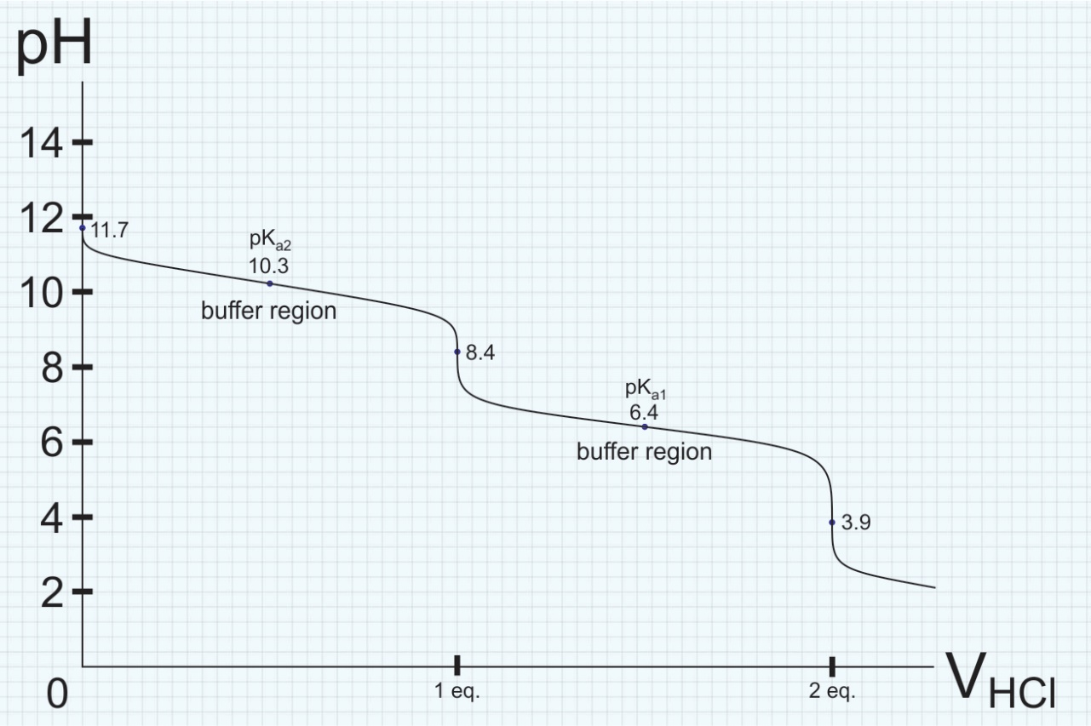
- The indicators should give different observable changes upon reaching each equivalence point. After reaching the first equivalent point, if the resulting color of the first indicator is not colorless, then we should use another indicator with a similar starting color for the second equivalence point. Table below shows the other indicator combinations that could be used in this titration.
1st equivalence point | 2nd equivalence point
Thymol blue (8.0 – 9.6)  Blue to yellow | α-Naphthyl red (3.7 – 5.0) or  p-ethoxycrisoidine (3.5 – 5.5)  Yellow to red
Thymol blue (8.0 – 9.6)  Blue to yellow | Methyl orange (3.1 – 4.4)  Orange to red
Phenolphthalein (8.0 – 10.0)  Pink to colorless | Bromphenol blue or tetrabromphenolblue (3.0 – 4.6)  Blue to yellow
Phenolphthalein (8.0 – 10.0)  Pink to colorless | α-Naphthyl red (3.7 – 5.0) or  p-ethoxycrisoidine (3.5 – 5.5)  Yellow to red
Phenolphthalein (8.0 – 10.0)  Pink to colorless | Methyl orange (3.1 – 4.4)  Orange to red

- After the first equivalence point, the mixture at a point consists of certain proportion of H₂CO₃ and HCO₃⁻:
HCO₃⁻(aq) + HCl(aq) H₂CO₃(aq) + Cl⁻(aq)
The pH value is governed by this equilibrium reaction:
H₂CO₃(aq) + H₂O(l) ⇄ HCO₃⁻(aq) + H₃O⁺(aq)
$$K_{a1}=\frac{\left[{{HCO}_{3}}^{-}\right]\left[{H_{3}O}^{+}\right]}{\left[H_{2}{CO}_{3}\right]}$$
Rearranging, we get the Henderson-Hasselbalch equation:
$$\left[{H_{3}O}^{+}\right]=K_{a1}×\frac{\left[H_{2}{CO}_{3}\right]}{\left[{{HCO}_{3}}^{-}\right]} \\ pH={pK}_{a1}+\log\left(\frac{\left[{{HCO}_{3}}^{-}\right]}{\left[H_{2}{CO}_{3}\right]}\right)$$
The pH value will be buffered as the ratio of [HCO₃⁻]/[H₂CO₃] does not vary by much (0.1 – 10) in the buffer region.
- Here is the reaction of the formation of CO₂:
H₂CO₃(aq) H₂O(l) + CO₂(g)
Boiling off CO₂ shifts the equilibrium to the formation of H₂CO₃, hence reducing the concentration of [H₃O⁺] and increasing the pH of the solution.
- Assuming that all CO₂ is boiled off, here is the back titration curve:
